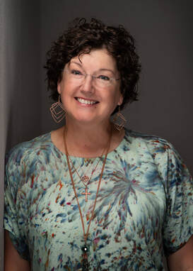
chop it like it’s hot workshop
Workshop fee: $40 BAQG members $50 non-members
$25 Kit fee

  - With Nina clotfelter
Mt. Olive Lutheran Church. 10310 Scarsdale Houston, TX
Wednesday, september 6, 2023 10 am – 4 pM
Sign up with Tina – tina.quilting@gmail.com
“We all have scraps left over from every project we do! Let’s make a BEAUTIFUL wall hanging with them! You’ll have a fun time practicing your free motion quilting, learning your sewing machine better, & learning about threads and playing with different types of threads. And here’s the best part…you ready…you can NOT do anything to make this project not be beautiful! That’s right! You can NOT mess this up!!! I PROMISE!!! $20 kit fee includes all kinds of embellishments for you to use (for this project and many others).”
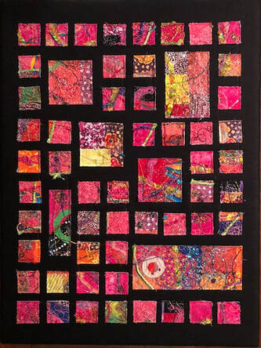
Bring a sack lunch OR we will place an order from Chicken Salad Chick.

