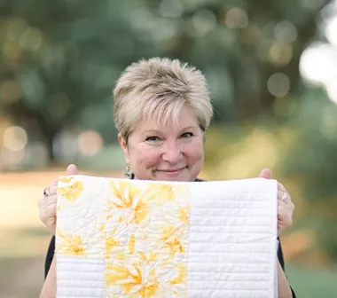
Boomerang Workshop
Workshop fee
$40 BAQG members
$50 non-members

  - With Glenda Wilder
Mt. Olive Lutheran Church. 10310 Scarsdale Houston, TX
Wednesday, June 7, 2023 10 am – 3 pM
Sign up with Tina – tina.quilting@gmail.com
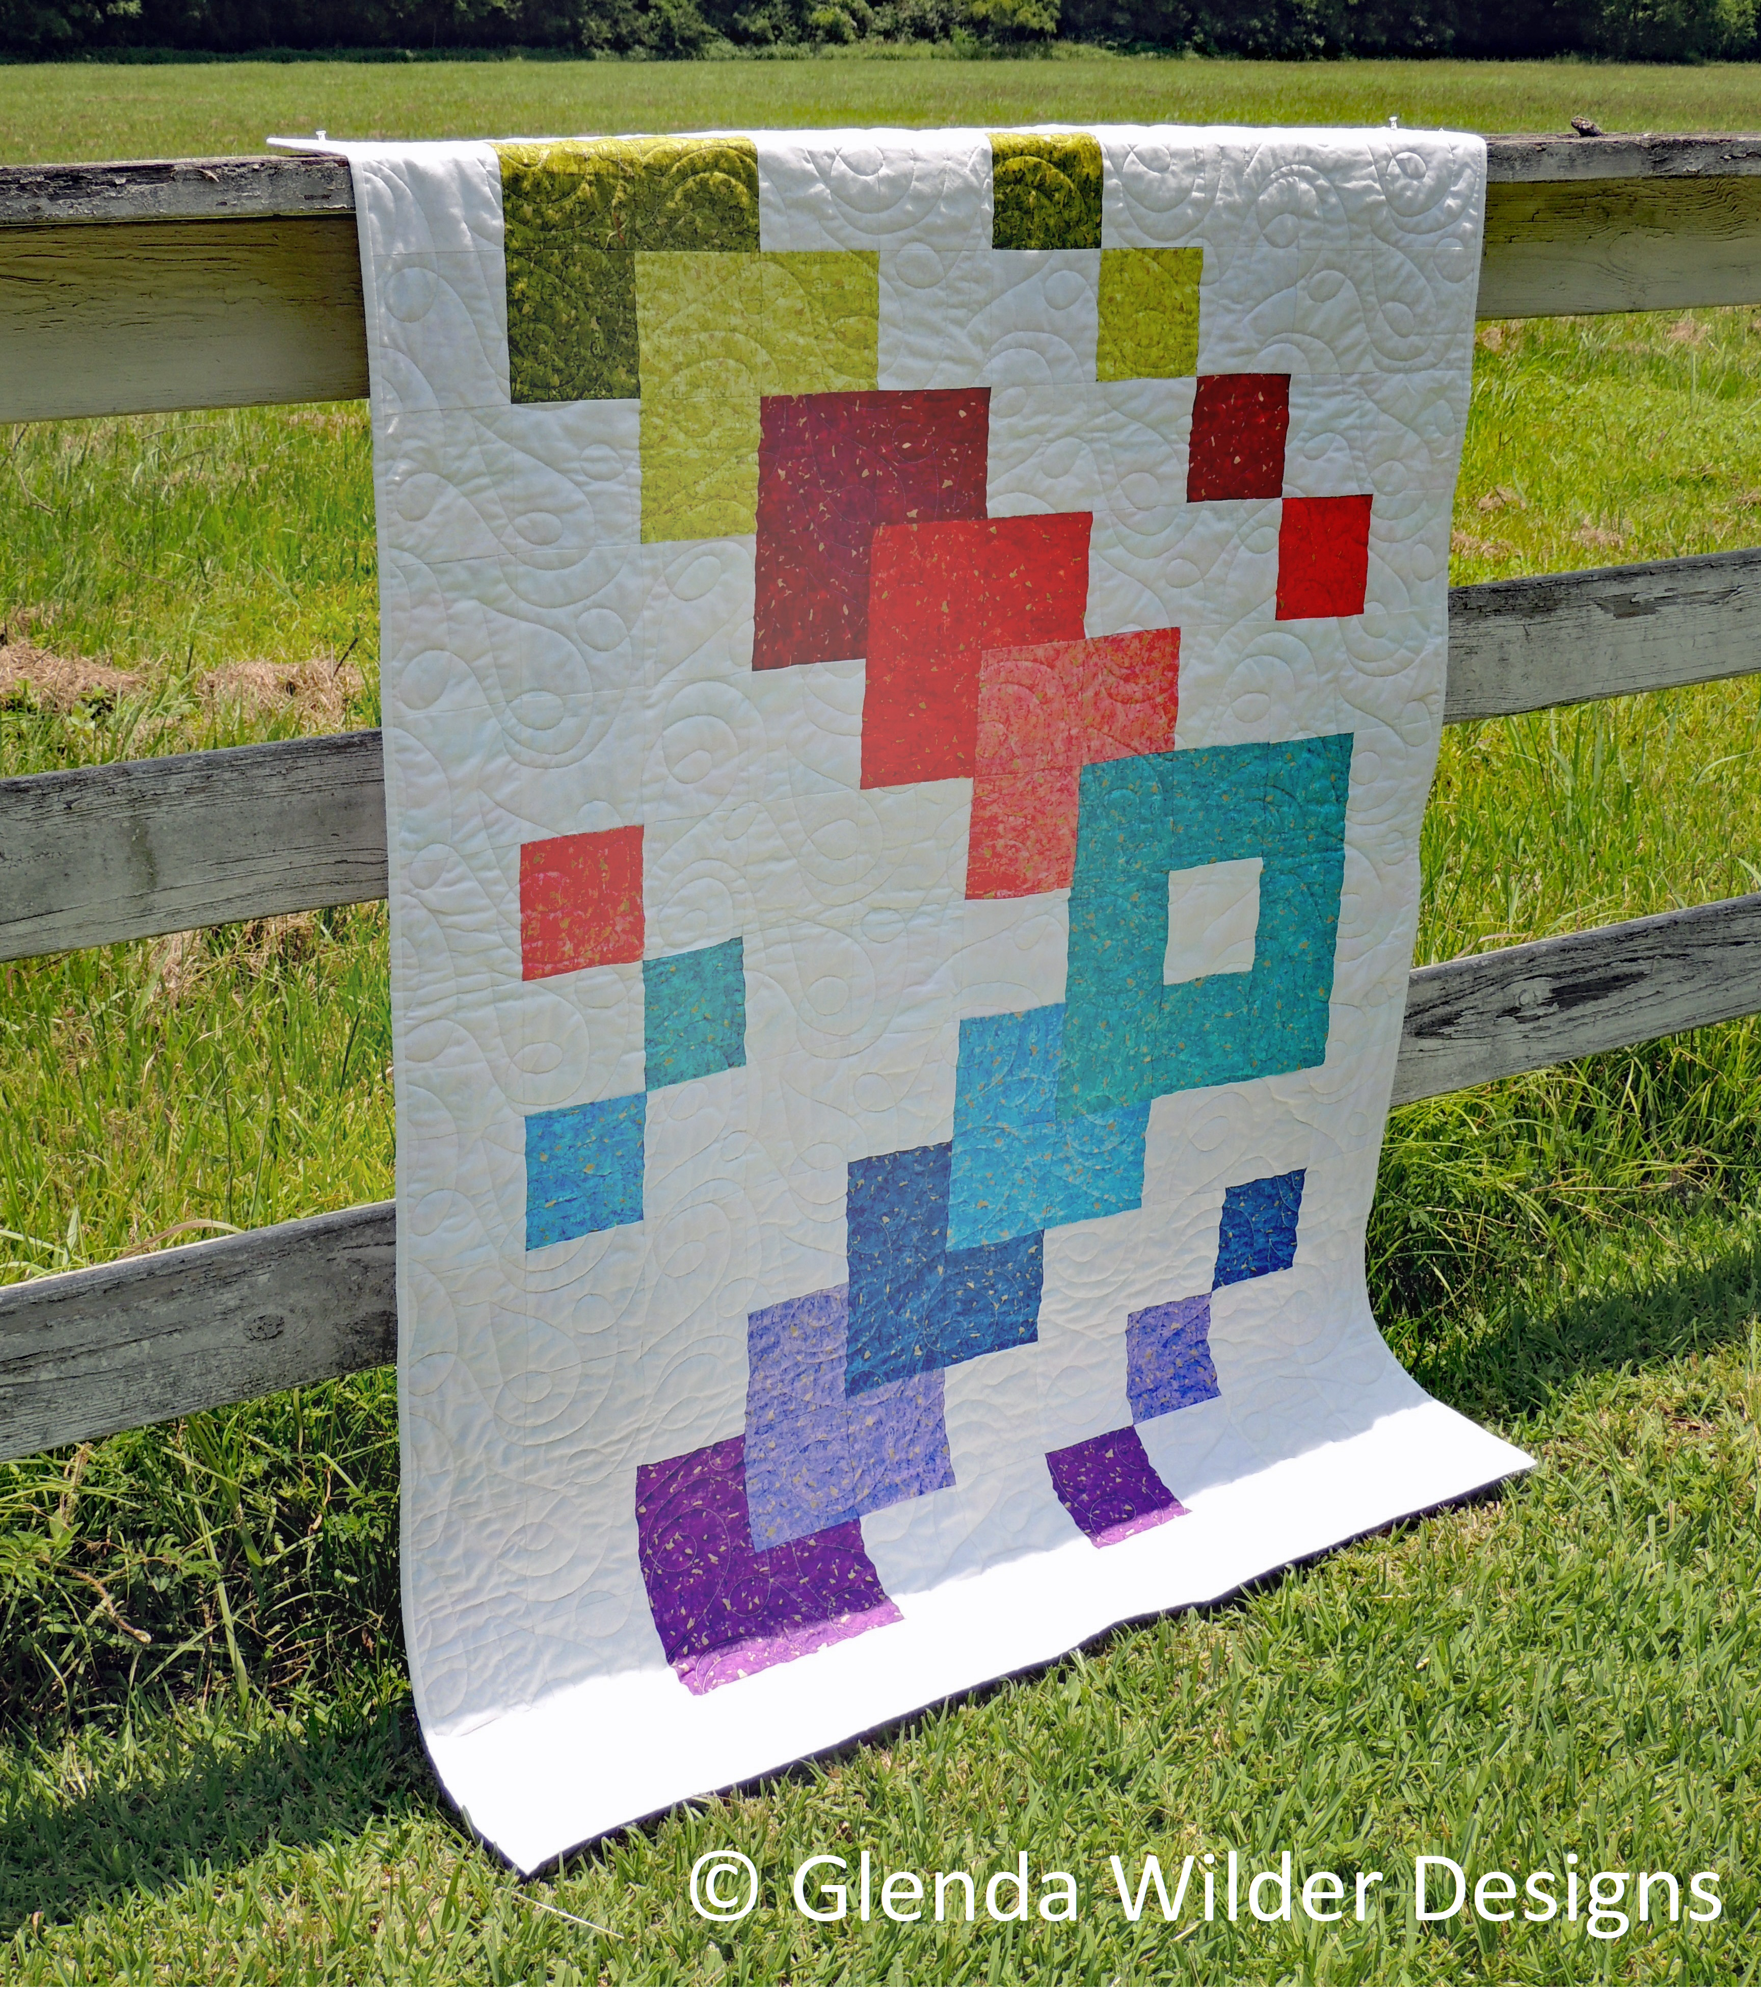
Bring a sack lunch OR we will place an order from Chicken Salad Chick.

