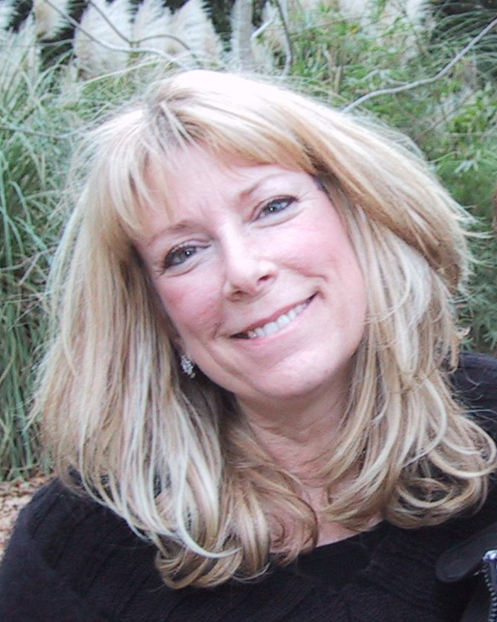
Stained glass workshop
Workshop fee: $40 BAQG members $50 non-members
TBD: Kit fee

  - With Carol Ann Maurer
Mt. Olive Lutheran Church. 10310 Scarsdale Houston, TX
Wednesday, August 2, 2023 10:30 am – 5 pM
Sign up with Tina – tina.quilting@gmail.com
Students will make a small wall hanging to learn the reverse appliqué method by machine.
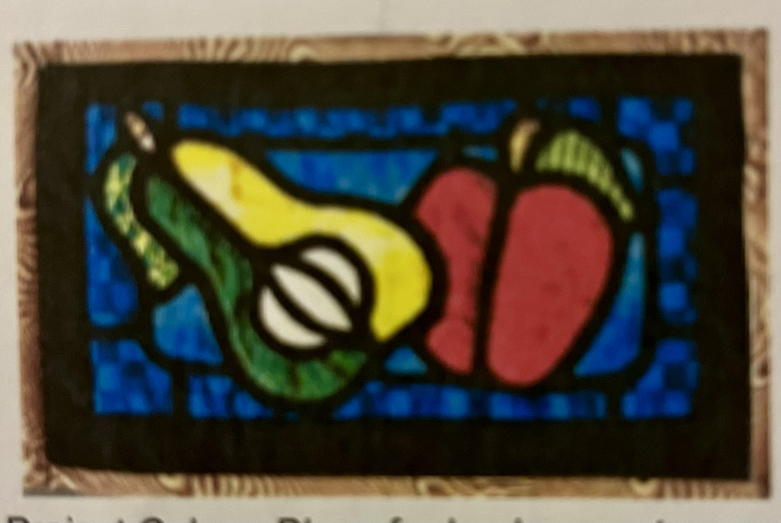
Bring a sack lunch OR we will place an order from Chicken Salad Chick.

